**Midterm Project README**

**Purpose, Aim and Objective:**

Face recognition-based attendance system is a process of recognizing the students face for taking attendance by using face feature matching based on high - definition monitor video and other information technology.

Every biometric system consists of enrollment process in which unique features of a person is stored in the database and then there are processes of identification and verification. These two processes compare the biometric feature of a person with previously stored template captured at the time of enrollment. Biometric templates can be of many types like Fingerprints, Eye Iris, Face, Hand Geometry, Signature, Gait and voice. Our system uses the face recognition approach for the automatic attendance of employees in the office room environment without employees’ intervention. Face recognition consists of two steps, in first step faces are detected in the image and then these detected faces are compared with the database for verification.

##### **Background of Project:**

Automatic face recognition (AFR) technologies have seen dramatic improvements in performance over the past years, and such systems are now widely used for security and commercial applications. An automated system for human face recognition in a real time background for a college to mark the attendance of their students. So, Attendance Marking Based on Face Identification is a real-world solution which comes with day-to-day activities of handling students. This method is secure enough, reliable and available for use.

**Scope of Project:**

Every biometric system consists of enrollment process in which unique features of a person is stored in the database and then there are processes of identification and verification. But our project provides facility for the automated attendance of students. Uses live face recognition to recognize each individual and mark their attendance automatically. Utilizes video and image processing to provide inputs to the system. Thus, enhancing the security for users.

##### **Modules Description:**

##### This project is composed of three main modules:

* **User module:** In this module, user will open camera and track images of every student to whom he wanted to take attendance through this application. For each tracking process it will take 60 images and then user should close training process. Once the process is done data will be stored in a folder 0, 1, 2 etc. for each user new folder is created. Also, it stores the details of user (id, name) in an excel file.
* **Training Process:** Once taking images process is done images from folder and for each image training process is done using OpenCV and yml file is stored in folder. This yml file is used for testing new images.
* **Detection Process:** In this process, when user opens camera it will track live images of user and convert user image to grey colour and check with face recognition model and then boxes are drawn on each face and features are verified with trained model and displays a box around the face with name and id.

Finally, attendance is marked to that user with correct date and time in an excel file.

**Software Requirements:**

The software requirements specify the use of all required software products like data management system. The required software product specifies the numbers and version. Each interface specifies the purpose of the interfacing software as related to this software product.

**Technology/Language** : Python.

**Operating System** : Windows, Linux, Mac.

**IDE** : Visual Studio Code/Sublime Editor.

**Front End** : Tkinter.

**Libraries** : OpenCV, Pandas, NumPy, datetime, PIL.

##### **Existing System:**

In the existing system, every organization has its own method in this regard. Some are taking attendance manually using the old paper or file-based approach. Some have adopted methods of automatic attendance using some biometric techniques.

##### **Drawbacks of Existing System:**

* But in these methods, people have to wait for long time in making a queue at time they enter the organization.
* Many biometric systems are available, but the key authentications are same as all the techniques.
* Every biometric system consists of enrollment process in which unique features of a person is stored in the database and then there are processes of identification and verification.

##### **Proposed System:**

The system consists of a camera that captures 60 images of the person at a time using OpenCV and saves those particular images for further process. After enhancement, it trains the machine to recognize the face using the collection of images captured before. This is shown in the experimental setup in Figure. Each person will be identified with a name and a unique ID. When the machine is trained perfectly, it will detect the faces during the time of attendance and logs the attendance for that particular person with complete date and time in an excel file.

##### **Advantages of the Proposed System:**

* In this way, a lot of time is saved, and this is highly secure process no one can mark the attendance of other.
* Attendance is maintained on the excel sheet so it can be accessed for purposes like administration, monitoring etc.

**How to execute:**

* Install the necessary python libraries.
* Use the command “**python3 train.py**”.

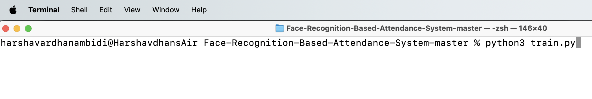

* The following Tkinter GUI window will be opened.

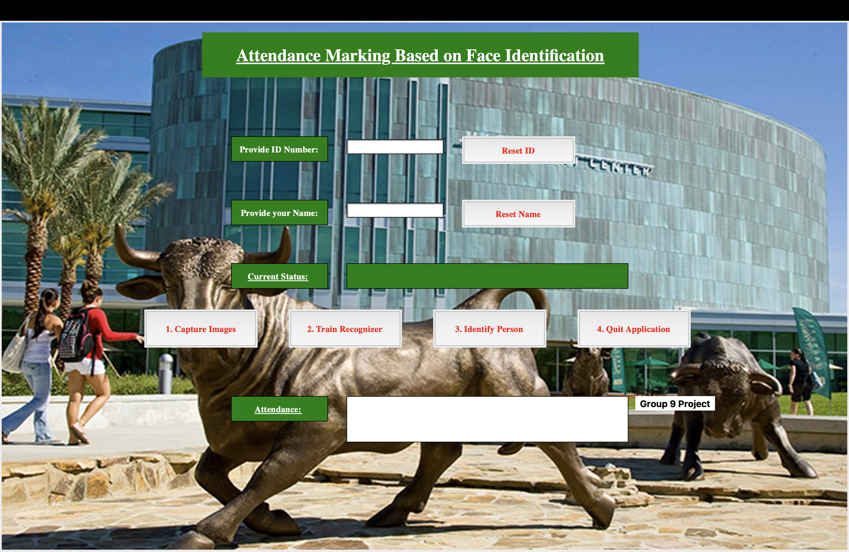

* Fill out details like ID and name. Corresponding validations have been added to both ID and Name entry fields.

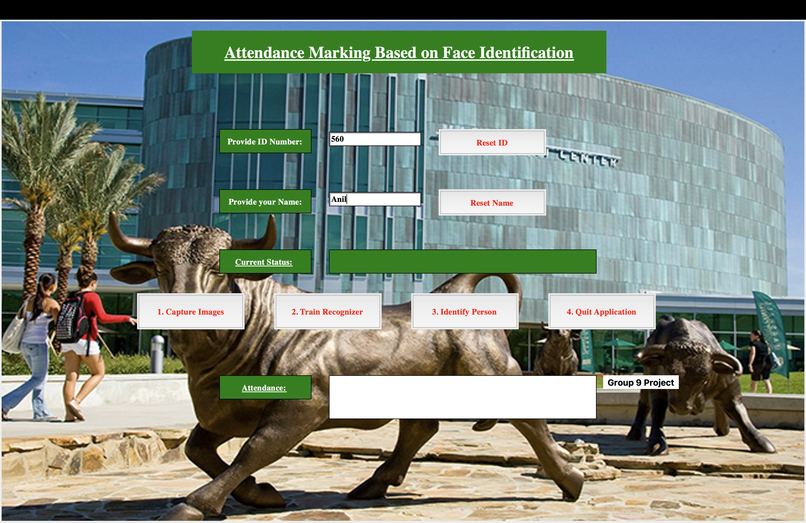

* Click on Capture Images. This operation will take 60 images of the user. It creates a Trainner.yml file in TrainingImageLabel folder.

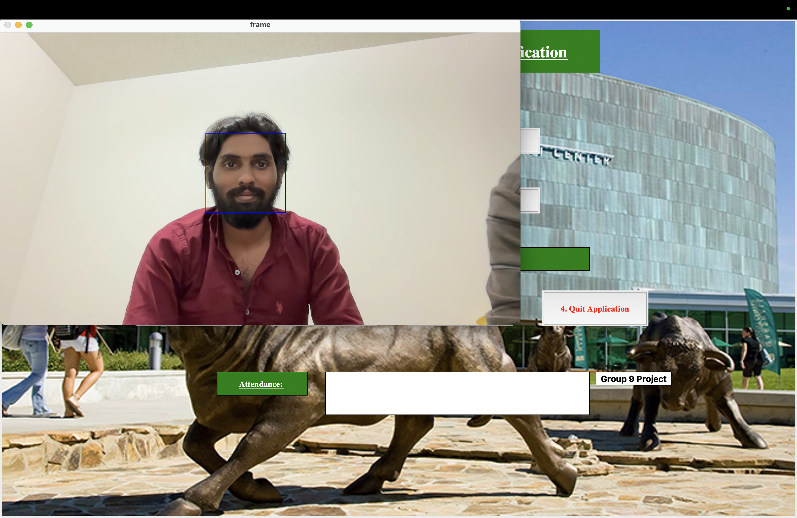

* Click on Train Recognizer to train the LBPH recognizer with the images.

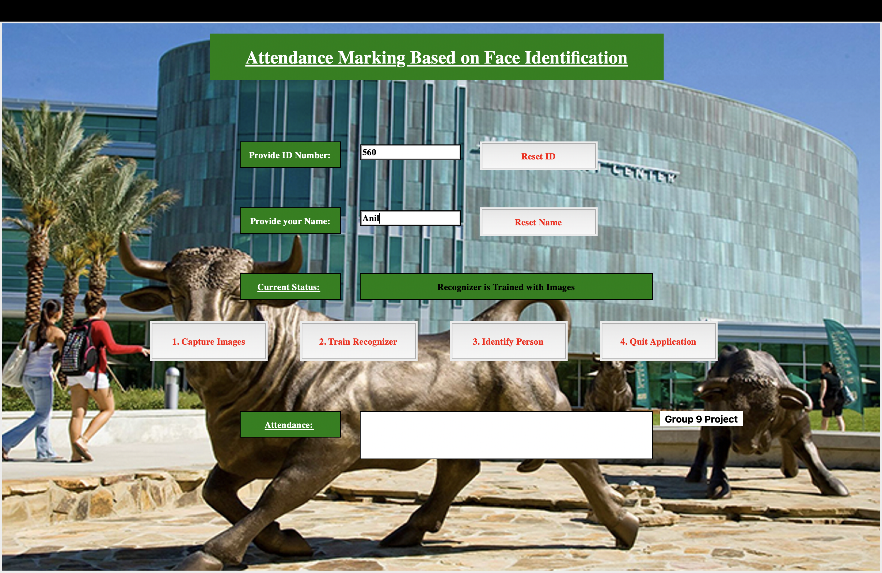

* Click on Identify person to track the person while marking the attendance.

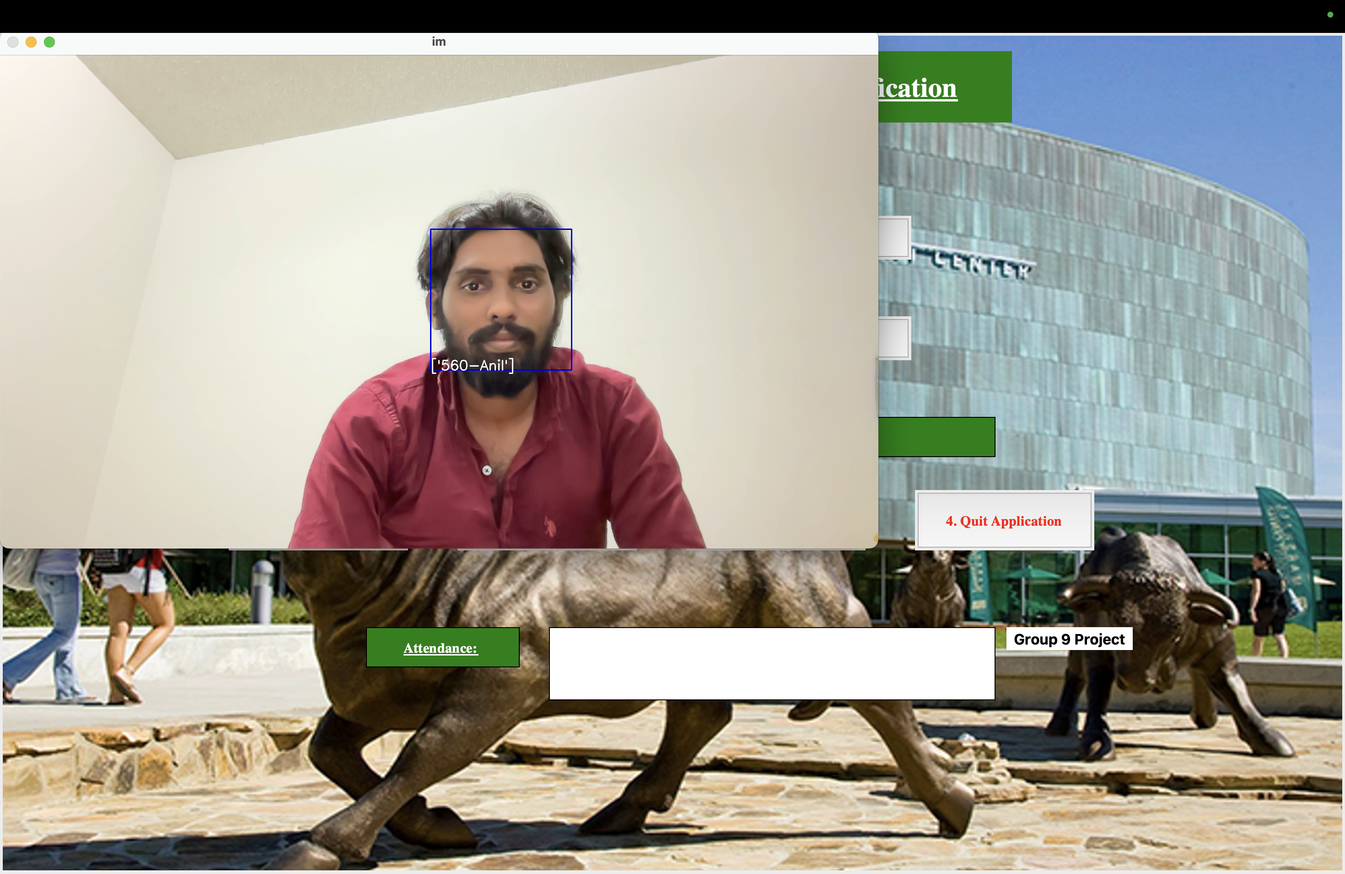

* Press the button ‘q’ in keyboard to mark the attendance. Attendance will be marked with timestamps and all the details will be displayed in the box beside the Attendance.

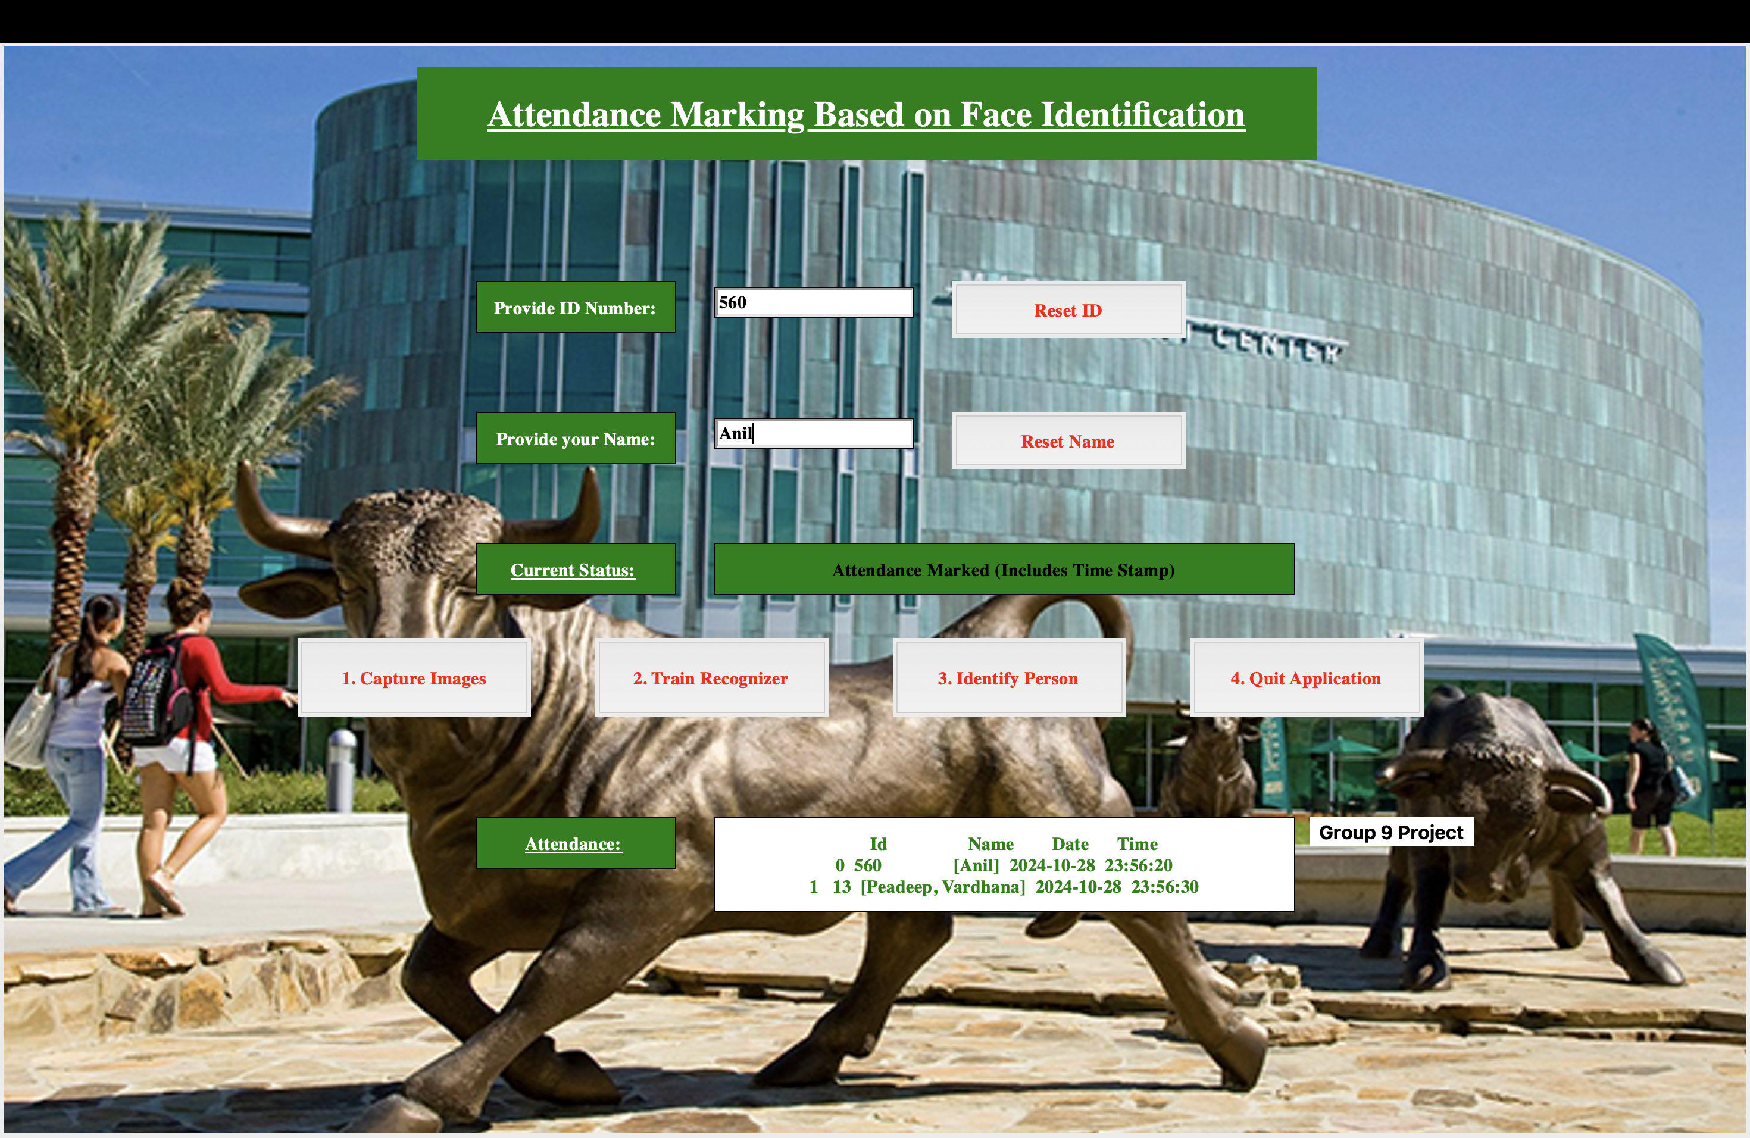

* Finally, click on Quit button to exit the window.
* Attendance for a specific person will be stored in a csv file created in Attendance folder.
* User details (Student in my case) will be updated in another csv file saved in Student details folder.